**Challenges faced by importers and exporters?**

**Financing**

Sourcing/manufacturing products overseas is not a cheap endeavour. For example, doing a test run can cost you thousands of dollars. When the time comes to scale production, you’ll need even more capital.  
  
To stay liquid, you may need to take out a [business loan](https://businessloancompanies.com/). If banks say no, private lenders offer easy access to hundreds of thousands of dollars, including [unsecured](https://businessloancompanies.com/unsecured/) access. With fast response times and flexible terms, you can access cash affordably when you need it.

### ****Supply Chain****

From the factory to your customer, countless hands touch your product. At any point, numerous things can go wrong. For instance, dockworkers could pack your products incorrectly, causing them to break on a rough ocean crossing. If your warehouse puts an incorrect bar code on your product, significant shipping delays can result

### ****Foreign Policy****

In your home country, rules and regulations change regularly. Now, expand that to every nation – eventually, one of your shipments will break a new/updated law. When that happens, your shipments may get held at the border. Even worse, they may get seized.

### ****Currency Risk****

A 1% shift in currency markets can suddenly leave you short. In previous years, movements like these were rare. These days, however, the world is rife with uncertainty. Nations seceding from political unions, unexpected election results, and disease outbreaks now occur with regularity.

**Solutions to improve imports?**

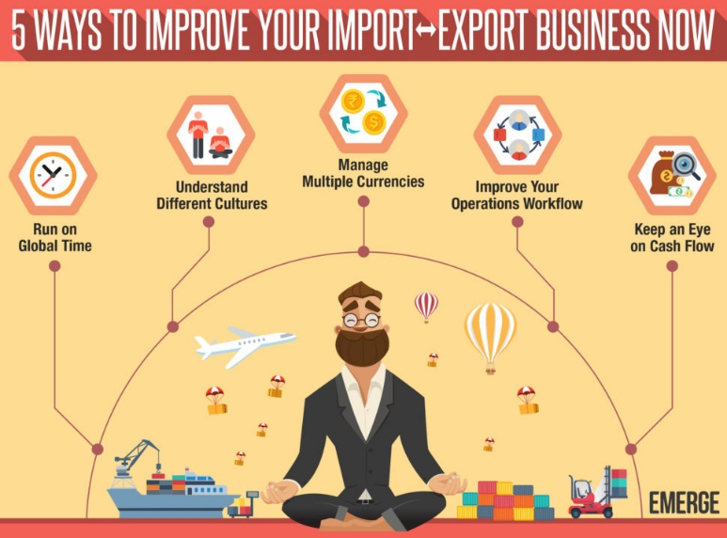

**Run on Global time -** Your import-export business runs 24/7. But you work 8–12-hour days. While you’re sleeping, the rest of the world is waking up to another day and business continues at a steady pace. As a small business owner, you know that having the “right stuff” or the right attitude towards your suppliers and buyers is critical. You work for them and not the other way around.

**Understand different Culture -** Nowadays it’s not enough to just keep track of different time zones. If you’re already dealing with different countries in your business, you probably have a good idea of the cultural nuances of each. Take the effort to understand each country’s culture in a deeper way, and pick up a few words in the process! **A little goes a long way** in building the relationship.

**Managing different curriencies -** It’s a given that you’re dealing in **multiple currencies** in your import-export business. It’s possible but very challenging to deal with different currencies if you’re still using paper or spreadsheets in your business. One good reason to use a software solution is to manage [multiple currencies](https://emergeapp.net/inventory-reports/multi-currency-erp/) for your customers, suppliers, sales and financial reports.

**Improve your operational workflow -** Another good reason to use inventory management software is to [introduce efficiencies into your operational workflow](https://emergeapp.net/sales/how-to-become-a-better-exporter-in-6-steps/) wherever possible. Why calculate **landed costs**or **CBM** manually when your software should do it for you? This is why DIY solutions such as spreadsheets don’t really address the technology issue. You’re simply digitizing a manual process.

**Keep an eye on cash flow -** Cash flow is the bane of any business, whether small or large. But as you know, for those doing international trade the risks are **magnified**. It may take months between purchasing goods overseas and converting them to sales, and thus cash, in your various markets. And during this time you will incur import-related expenses upfront that needs to be paid now.

**Major Import & Export items for India?**

**Import**

Mineral fuels including oil: US$168.6 billion (33.2% of total imports)

Gems, precious metals: $65 billion (12.8%)

Electrical machinery, equipment: $52.4 billion (10.3%)

Machinery including computers: $43.2 billion (8.5%)

Organic chemicals: $22.6 billion (4.4%)

Plastics, plastic articles: $15.2 billion (3%)

Iron, steel: $12 billion (2.4%)

Animal/vegetable fats, oils, waxes: $10.2 billion (2%)

Optical, technical, medical apparatus: $9.5 billion (1.9%)

Inorganic chemicals: $7.3 billion (1.4%)

**Export**

* Petroleum products. Value – 61.2 billion dollars
* Jewellery. Value – 41.2 billion dollars
* Automobile. Value – 14.5 billion dollars
* Machinery. Value – 13.6 billion dollars
* Bio-chemicals – 12 billion dollars
* Pharmaceuticals – 11.7 billion dollars
* Cereals - 10.1 billion dollars
* Iron and steel – 9 billion dollars
* Textile – 9 billion dollars
* Electronics – 9 billion dollars